Task 01:

Code:
INCLUDE Irvine32.inc

.data
arr DWORD 1,2,3,4,5

.code
main PROC

mov esi, OFFSET arr
mov edi, OFFSET arr + SIZEOF arr - TYPE arr
mov ecx, LENGTHOF arr / 2

L1:
mov eax, [esi]
mov ebx, [edi]

mov [esi], ebx
mov [edi], eax

add esi, TYPE arr
sub edi, TYPE arr
loop L1

mov esi, OFFSET arr
mov ecx, LENGTHOF arr
mov ebx, TYPE arr

call DumpMem

exit
main ENDP
END main

Output:
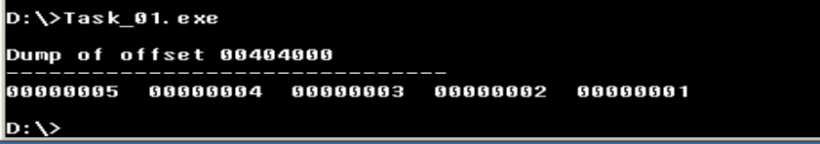

Task 01B:

Code:
INCLUDE Irvine32.inc

.code
main PROC
mov ecx, 5
mov ebx, 1

OuterLoop:
push ecx
mov ecx, ebx

InnerLoop:
mov al, '*'
call WriteChar
loop InnerLoop

call Crlf
inc ebx
pop ecx
loop OuterLoop

exit
main ENDP
END main

Output:
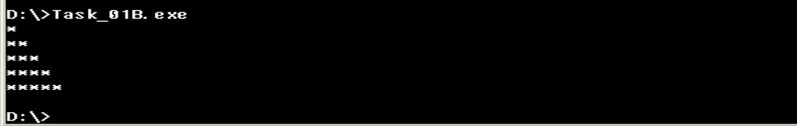

Task 02:

Code:
INCLUDE Irvine32.inc

.data
Uarray WORD 1000h,2000h,3000h,4000h
Sarray SWORD -1,-2,-3,-4

.code
main PROC

mov esi, OFFSET Uarray
mov ax, [esi]
movzx eax, ax
mov bx, [esi+2]
movzx ebx, bx
mov cx, [esi+4]
movzx ecx, cx
mov dx, [esi+6]
movzx edx, dx
call DumpRegs

movsx eax, Sarray
movsx ebx, Sarray+2
movsx ecx, Sarray+4
movsx edx, Sarray+6

call DumpRegs

exit

main ENDP
END main

Output:
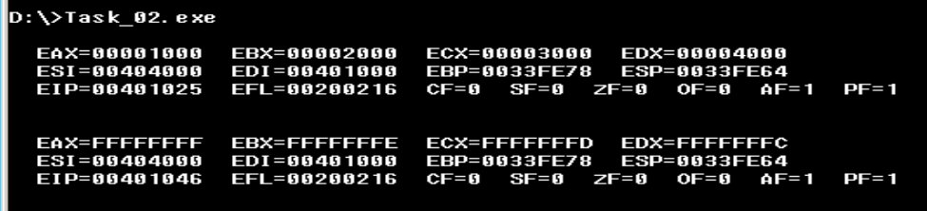

Task 03:

Code:
INCLUDE Irvine32.inc

.data
myArray BYTE 10h, 20h, 30h, 40h, 50h, 60h, 70h

.code
main PROC

mov esi, OFFSET myArray
mov edi, OFFSET myArray + SIZEOF myArray - TYPE myArray
mov ecx, LENGTHOF myArray / 2

ReverseLoop:

mov eax, [esi]
mov ebx, [edi]
mov [esi], ebx
mov [edi], eax

add esi, TYPE myArray
sub edi, TYPE myArray

loop ReverseLoop

mov esi, OFFSET myArray
mov ecx, LENGTHOF myArray
mov ebx, TYPE myArray
call DumpMem
exit
main ENDP
END main

Output:
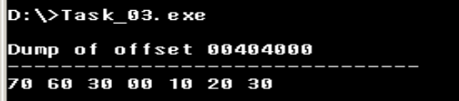

Task 04:

Code:
INCLUDE Irvine32.inc

.code
main PROC
mov eax, 1
mov ebx, 0
mov ecx, 7

FibLoop:
call DumpRegs
mov edx, eax
add eax, ebx
mov ebx, edx

loop FibLoop

exit
main ENDP
END main

Output:
